Proposed system:
Provides stock inventory in car accessories such as mirrors, lubricants…etc.
This website also provides payroll processing for the employees.
Provides services for the customer such as:-
- Periodic services
- Denting and painting
- Car spa and cleaning
Builds stronger relationship with the customers.
An email is sent to the customers after purchasing their items.
No time delay in response i.e if the customer wants to know any details of the products or services , they can ask any queries in contact us form.
Cash on delivery is available for the customers after purchasing their products.
If the customer cancel their products ,a cancellation email is send to their perspective mail-id.
ADVANTAGES
- Cost effective and time saving.
- The services are given at the doorstep so the customers no need to go to the shop

Level 2 DFD:
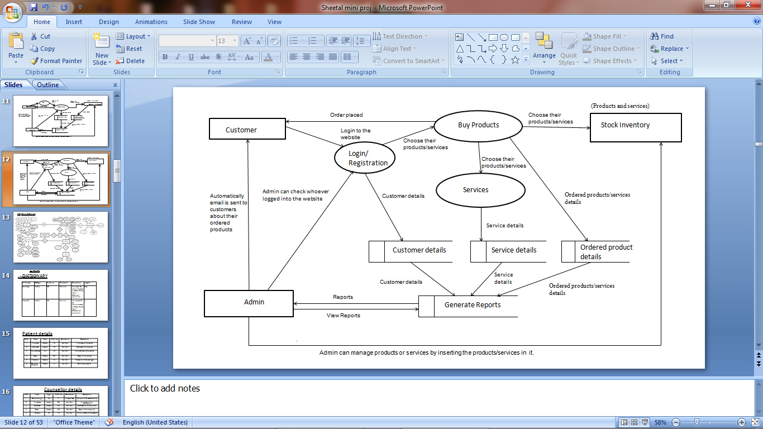

ER DIAGRAM:
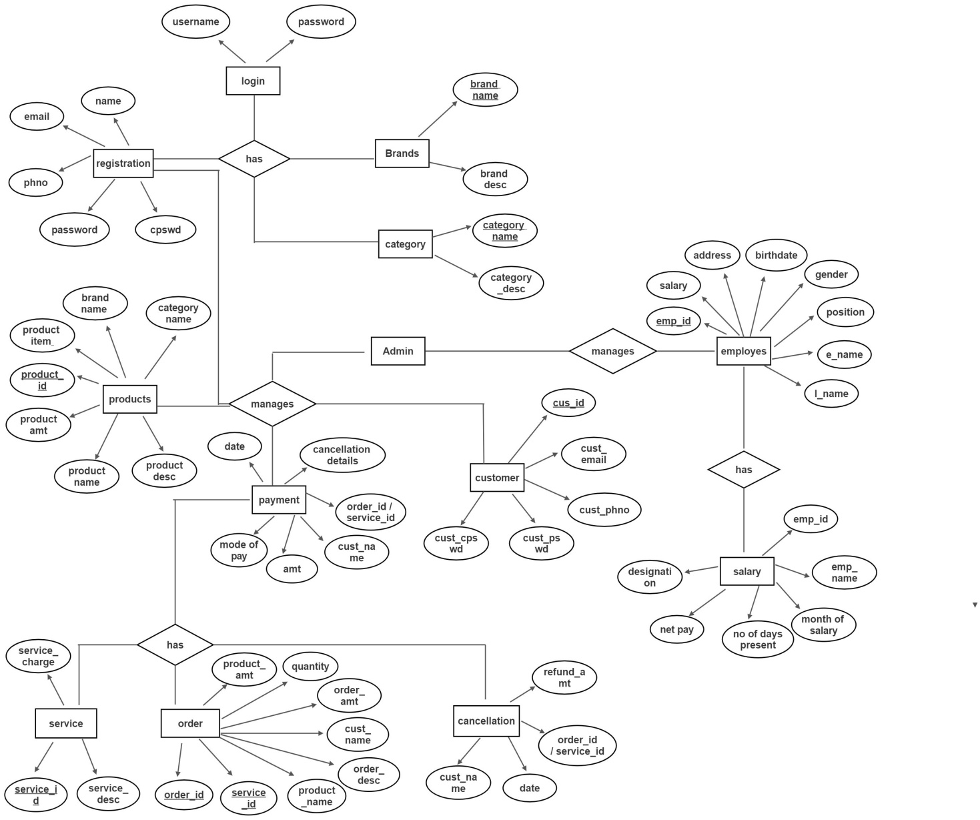

DATA DICTIONARY:
Login table :

Customer details

Field name | Datatype | Field size | Constraint | Description
Username | Varchar | 20 | Not null | Username used by customers
Password | Varchar | 20 | Not null | password used by customers
Field name | Datatype | Field size | Constraint | Description
Cust_Id | Int | 10 | Primary key | Id of the customer
Cust_name | Varchar | 10 | Primary key | Name of the customer
Cust_email | Varchar | 30 | Not null | Email of the customer
Cust_phno | Varchar | 10 | Not null | Phone number of the customer
Cust_pswd | Varchar | 10 | Not null | Password of the customer
Cust_cpswd | Varchar | 10 | Not null | Confirm password of the customer

Product details
Field name | Datatype | Field size | Constraint | Description
Product_id | Int | 10 | Primary key | Id of the Product
Category name | Varchar | 20 | Foreign key | Name of the product category
Brand name | Varchar | 20 | Foreign key | Brand name of the product
Product name | Varchar | 10 | Not null | Name of the product
Product amt | Int | 30 | Not null | Amount of the product
Product items | Varchar | 20 | Not null | Items of the product
Product desc | Varchar | 50 | Not null | Description of the product
Field name | Datatype | Field size | Constraint | Description
Brand name | varchar | 10 | Primary key | Name of the brand
Brand desc | varchar | 50 | Not null | Description of the brand
Brand details

Category details
Field name | Datatype | Field size | Constraint | Description
Category  name | varchar | 10 | Primary key | Name of the category
Category  desc | varchar | 50 | Not null | Description of the  category
Order details
Field name | Datatype | Field size | Constraint | Description
Order_id | Int | 10 | Primary key | Id of the order
Service_id | Int | 10 | Primary key | Id of the service
Product_name | Varchar | 10 | Not null | Name of the product
Product_amt | Varchar | 50 | Not null | Amt of the product
Quantity | Int | 10 | Not null | Quantity of products
Order_amt | Int | 10 | Not null | Amount of the order
Cust_name | Varchar | 10 | Not null | Name of the customer
Order_desc | Varchar | 50 | Not null | Description of the order

Service details
Field name | Datatype | Field size | Constraint | Description
Service_id | Int | 10 | Not null | Id of the service
Service_desc | Varchar | 50 | Not null | Description of the  service
Service_charge | Int | 10 | Not null | Amount to be payed for the service

Payment details
Field name | Datatype | Field size | Constraint | Description
Order_id/  Service_id | Int | 10 | Foreign key | The id of the order
Cust_name | Varchar | 10 | Foreign key | Name of the customer
Amount | Int | 20 | Not null | Amount to be payed by the  customer
Mode of  pay | Varchar | 10 | Not null | Mode of payment
Date | date | 10 | Not null | Date of payment

Cancellation details
Field name | Datatype | Field size | Constraint | Description
Order_id/  Service_id | Int | 10 | Foreign key | The id of the order
Cust_name | Varchar | 10 | Foreign key | Name of the customer
Date | date | 10 | Not null | Date of payment
Refund  Amount | Int | 20 | Not null | Amount to be  refunded

Employee details for Payroll process
Field name | Datatype | Field size | Constraint | Description
Emp_id | Int | 10 | Primary key | Id of the employee
First_name | Varchar | 10 | Not null | First name of the employee
Last_name | Varchar | 10 | Not null | Last name of the employee
DOB | Date | 10 | Not null | Date of birth
Address | Varchar | 30 | Not null | Present Address of the  employee
Gender | Varchar | 10 | Not null | Gender of the employee
Position | Varchar | 10 | Not null | Position mentioned for the  employee
Schedule | Varchar | 10 | Not null | Schedule of the employee
Salary | Int | 20 | Not null | Salary of the employees

Salary details of Employee

Field name | Datatype | Field size | Constraint | Description
Emp_id | Int | 10 | Foreign key | Id of the employee
Emp_name | Varchar | 10 | Not null | Name of the employee
Designation | Varchar | 10 | Not null | Designation of the employee
Net pay | Int | 20 | Not null | How much of the amount taken  divided by 30
Month of  salary | Int | 20 | Not null | Month the salary is distributed
No of days  present | Int | 30 | Not null | No of days present by the employee

TABLE RELATIONSHIP:
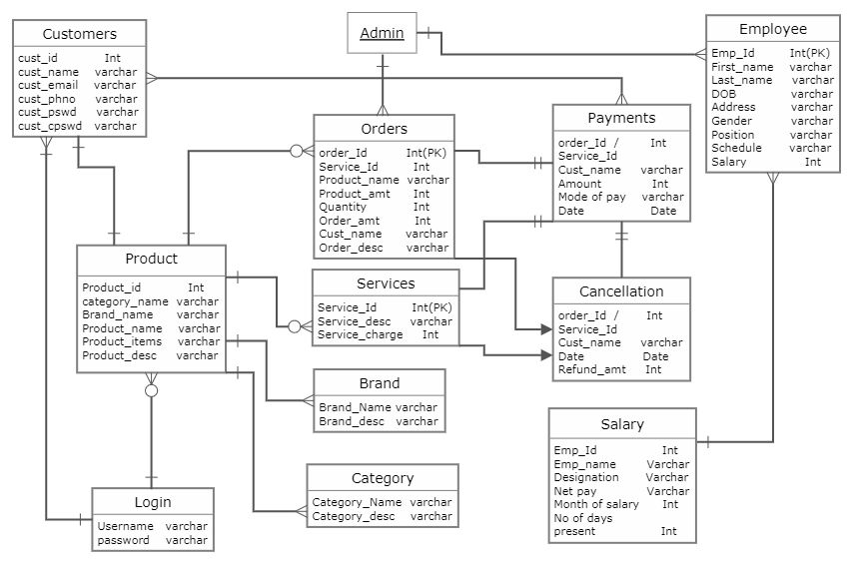

MODULAR DESCRIPTION:
Admin:
The admin can manage login details. The admin manages user permission and the users whoever logged into the system. He also manages employee details and their daily wages. Manages and track notification system. Manages all the other details(Customer details, employee details...etc)
Customer:
A customer needs to give the registration details such as (name, email, phno, pswd, cpswd).After registering they are asked to login to the website. Then they can purchase or order the required items or services.
Products:
A product module has brand name and category name which is used for creating a product category and inserting the products into it. Each product has its own specifications, price and descriptions. After inserting a product which is done through admin panel , it is asked to upload the images of the products. The products will be displayed in the website with the category name and its descriptions.
Category:
A category module contains category name and description. Each category has also a subcategory which is used for inserting the products.
Brand :
A brand module contains brand name and description. Each brand name represents the product brand and their items.
Order Details Module:
After the customer purchase the items their order ID and their order type would be shown in order history. The customer can also track their order with their order ID.

Service Details Module:
After the customer purchase for the required service , their service ID would be shown in order history. The customer will receive service at the date and time they have mentioned.
Payment Module:
The customer will be directed to Razor-pay after they proceed to checkout their order or service.The customer needs to enter their card details, their email and phone-no. Date of payment will be mentioned.
Cancellation:
If the customer needs to cancel the order or service , they can cancel their order/service underneath the placed order/service which will be mentioned. After the customer cancel their order/service they will receive a Cancellation Mail.
Employee Module in Payroll process:
The Employee details will be managed in the admin side. The admin will enter all the employee details. For Each employee an Emp_Id is created. After entering the details employee id will be generated. The employee must enter the employee id in which time they come and in which time they leave. The employee’s salary , deduction, net-pay and gross pay will be calculated. The payroll will be generated after the calculation and then they can take a print of it.
Salary Details Of Employee:
For salary details , the employee’s Emp_id, Emp_name and their designation is collected. Net pay is calculated according to the salary which they earn and is lessed by No of days they were not present. Month of salary in which date they have received. No of days they have been present will also be noted.

